Open Rollmaster software, enter in login information
Company ID: 99
Password: TEST
Branch ID: 1
User ID: SALESR1
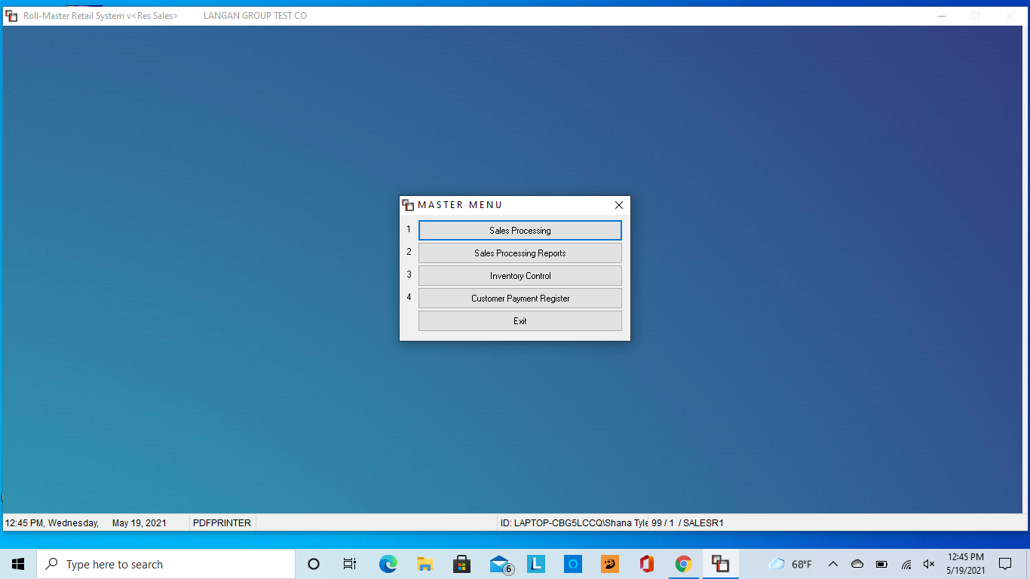
Click sales processing
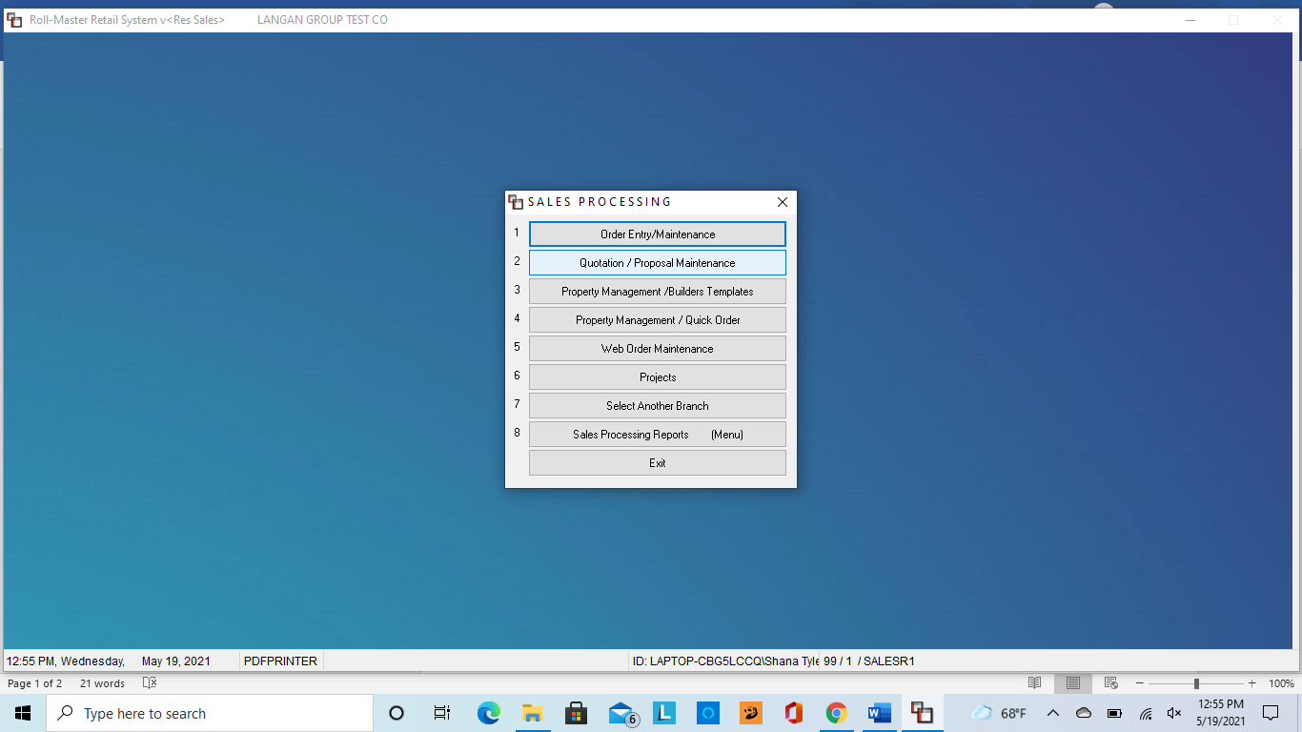
Then Quotation/Proposal Maintenance
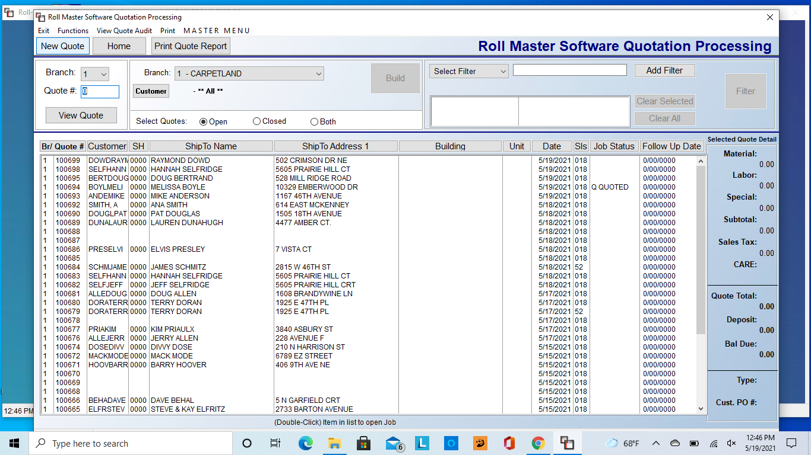
Click New Quote
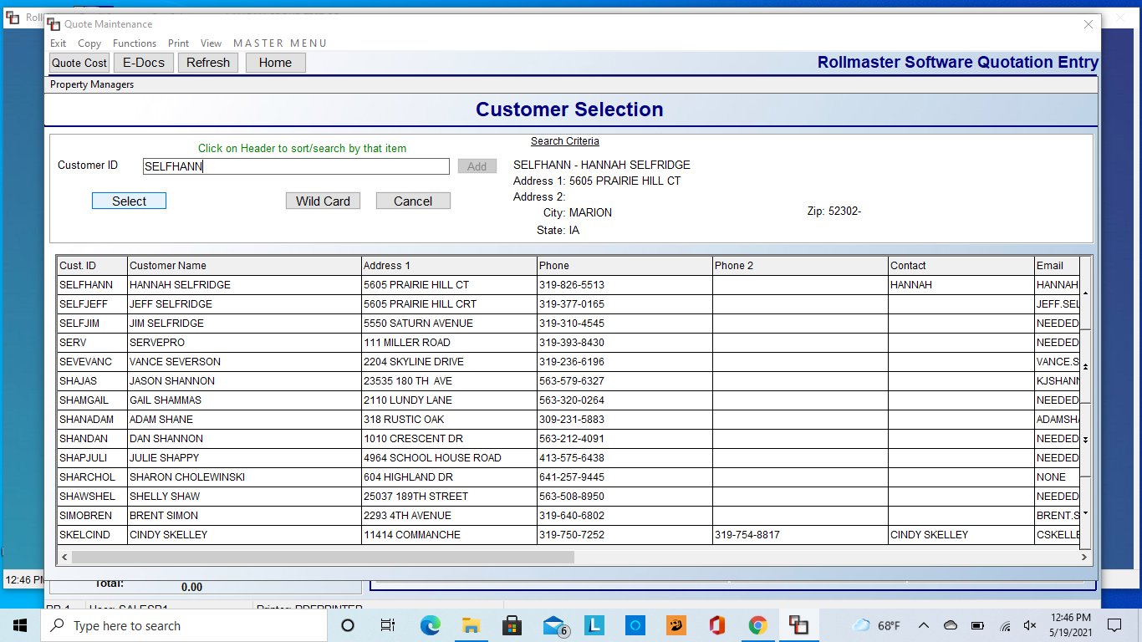
Type in customer ID, consisting of first 4 of the last name and first 4 of the first name of the customer. If the customer is not in the database yet, click add. If they are, select their name
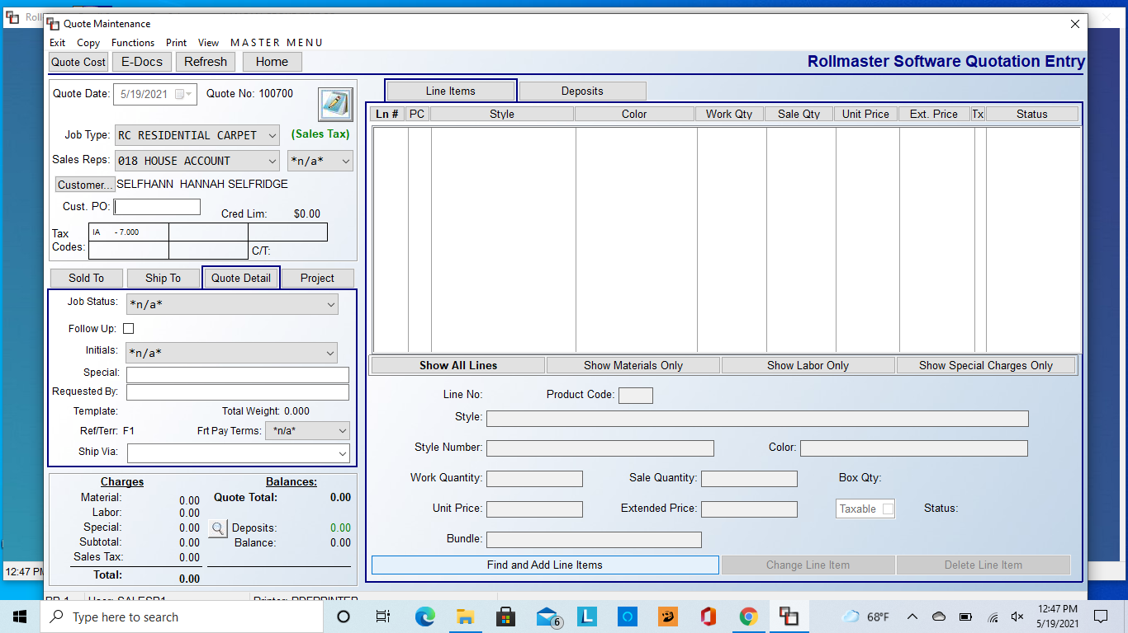
Select job type and salesman (in test mode, you don’t necessarily need to do this)
Click on Find and Add Line Items
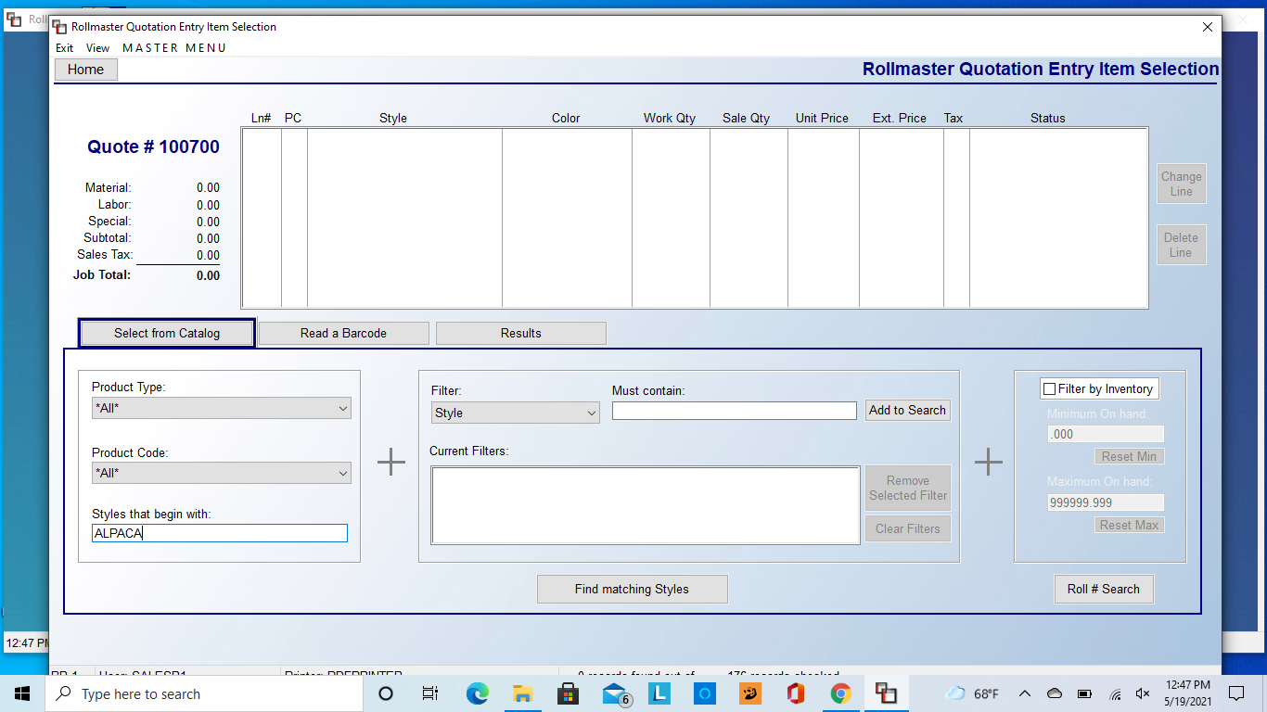
Type in the style name of the product. There are other ways to narrow it down if this brings up too many options
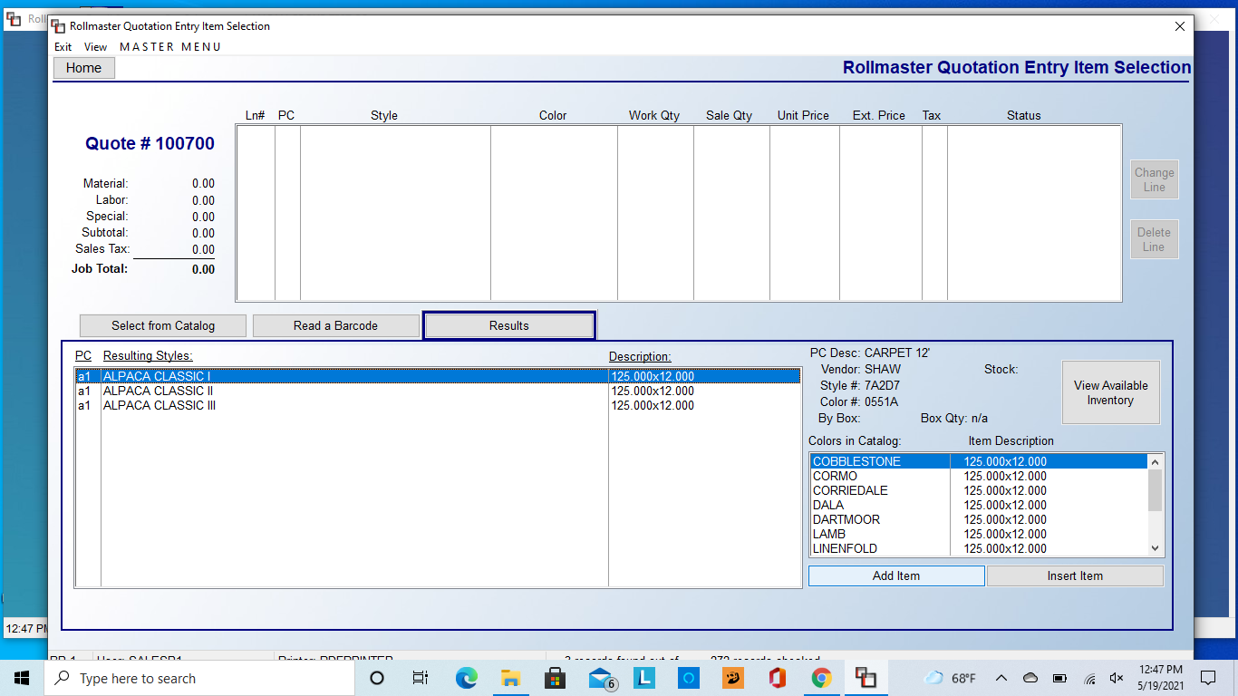
Select the product that you are looking for on the left side, and then the color on the right side. Hit add item once both are selected
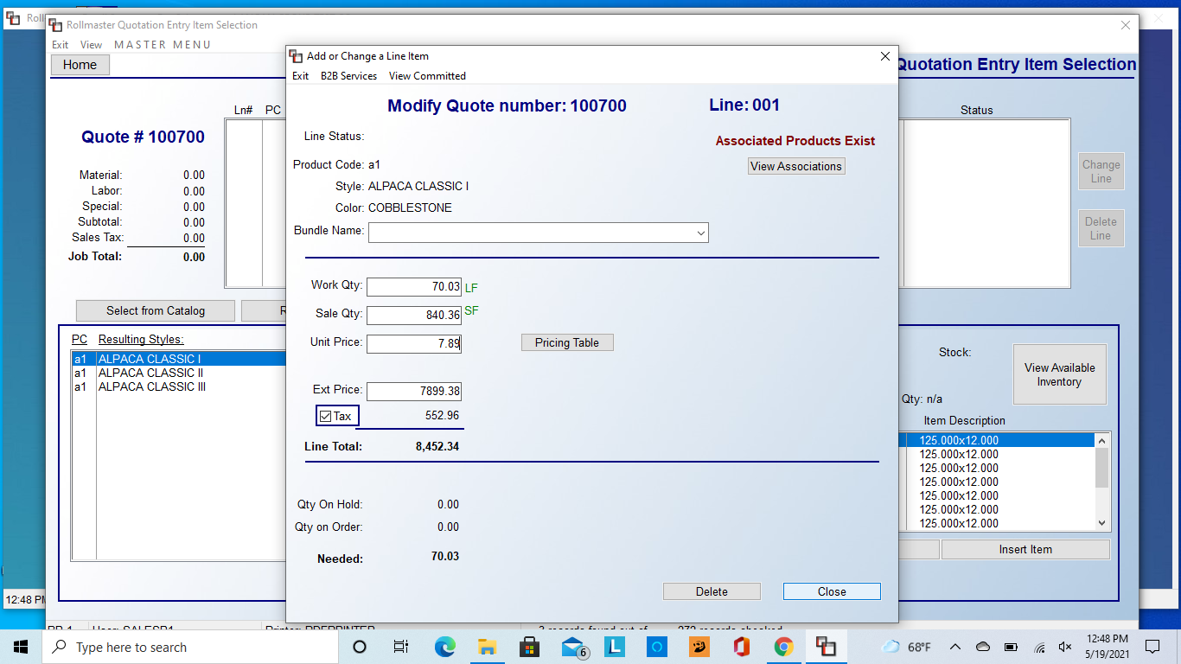
Enter in the work quantity (in linear feet, i.e. 12 x 70.03 lf)
Hit tab, and the software will figure and enter in the square footage for you
In unit price, enter in the correct price per square foot if it is not listed correctly.
Once you have done all those steps, hit the Close button
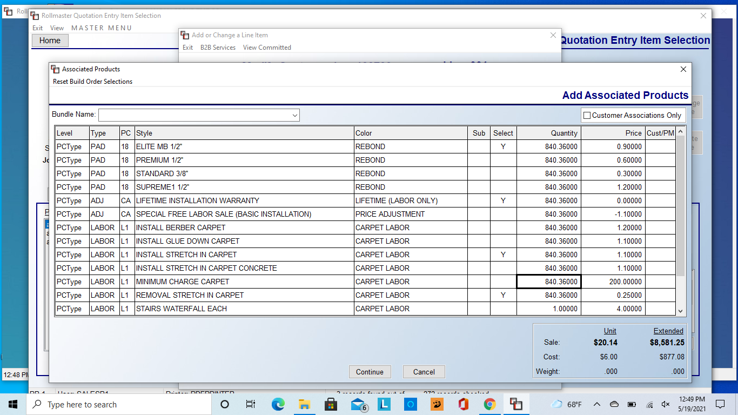
Associated products will automatically pop up.
In this screen, you will select pad, removal of old and installation of new product, as well as furniture moving. You can change quantities as need in the Quantity column.
Once you have selected everything you need, hit the Continue button.
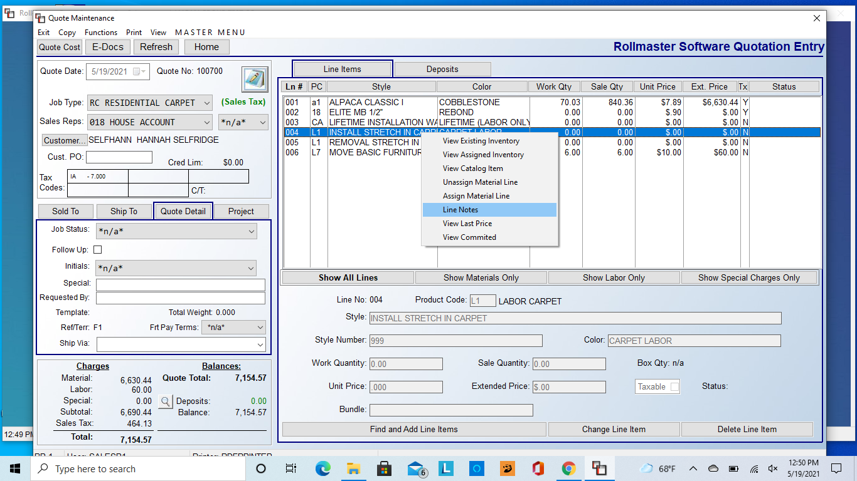
To add installation notes, select the installation line and right click on it. Select Line Notes
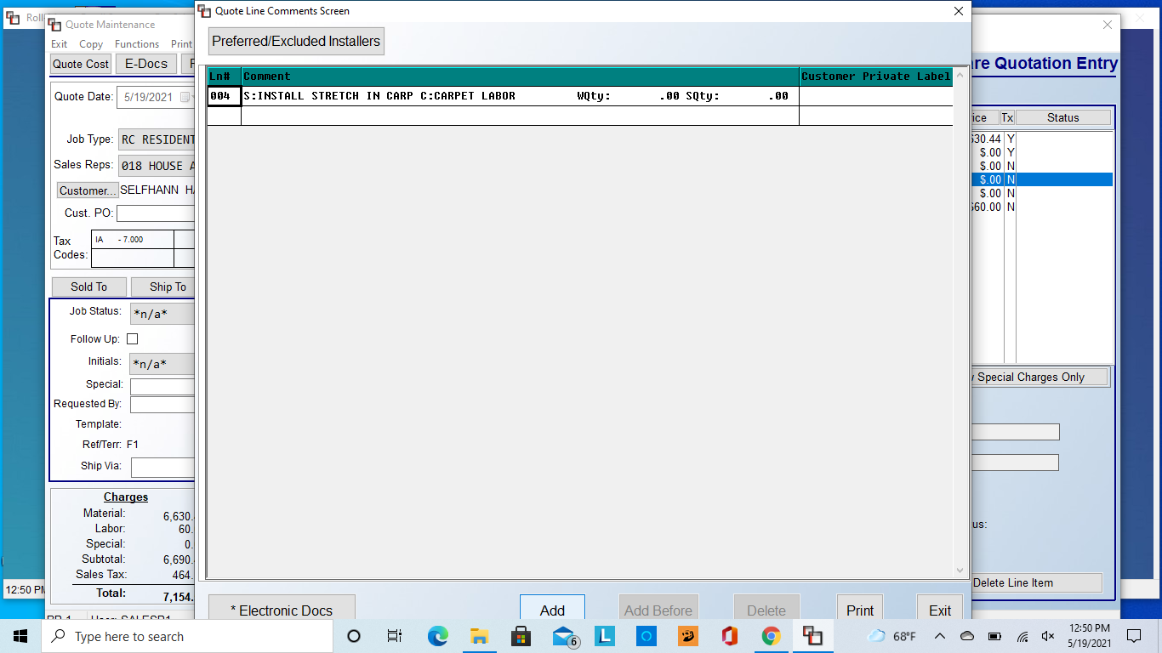
This screen will pop up, hit Add at the bottom of the screen
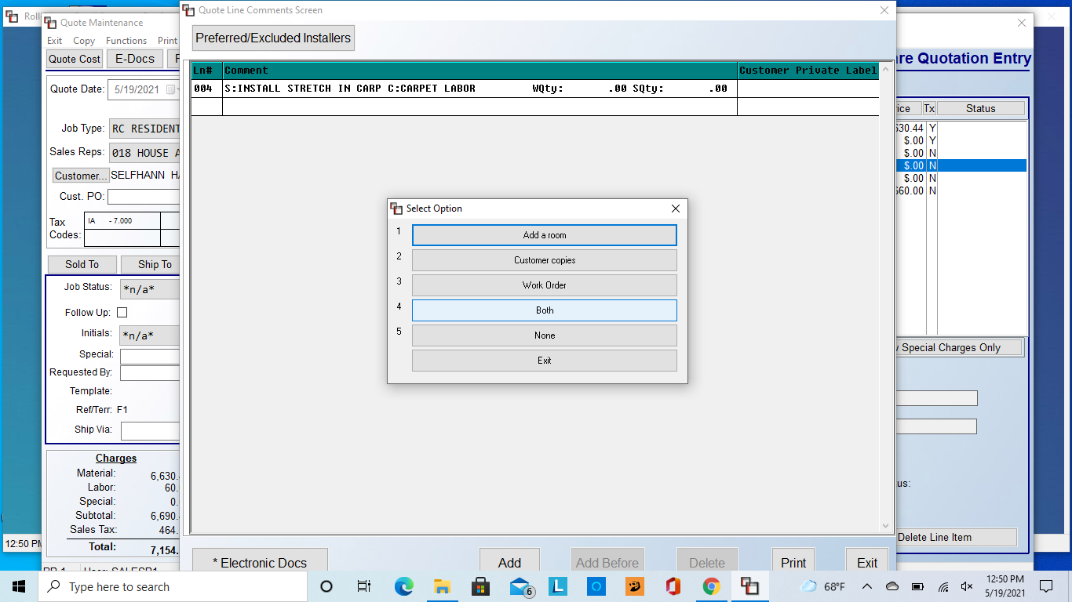
Select Both, as this will put the note on the contract and on the work ticket
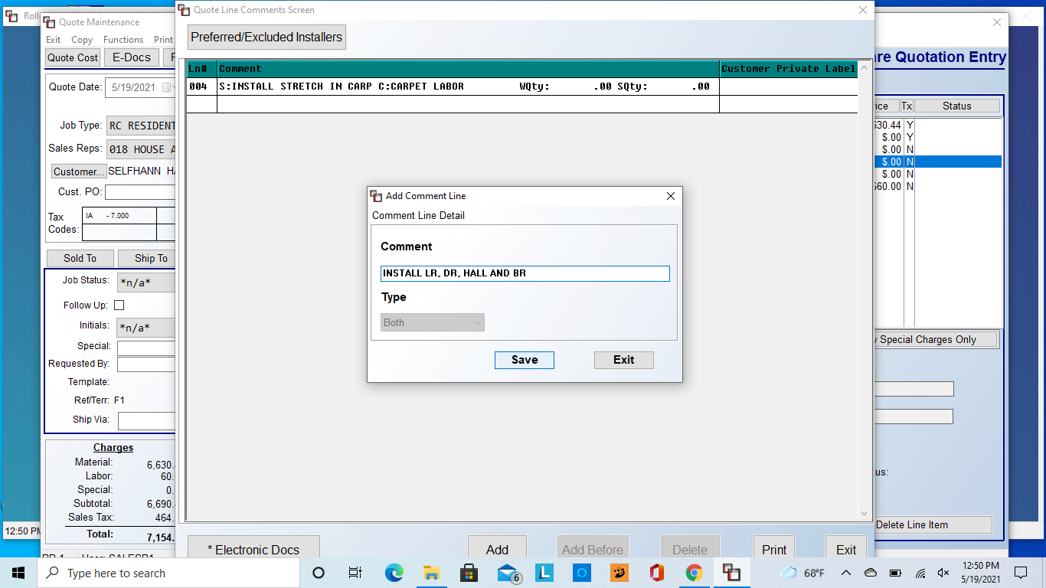
Type in any installation notes and then select Save. If you need to add another note, a comment box will automatically pop up. Once you are completely done adding notes, hit Exit on both the small comment box and the larger Quote Line Comments Screen
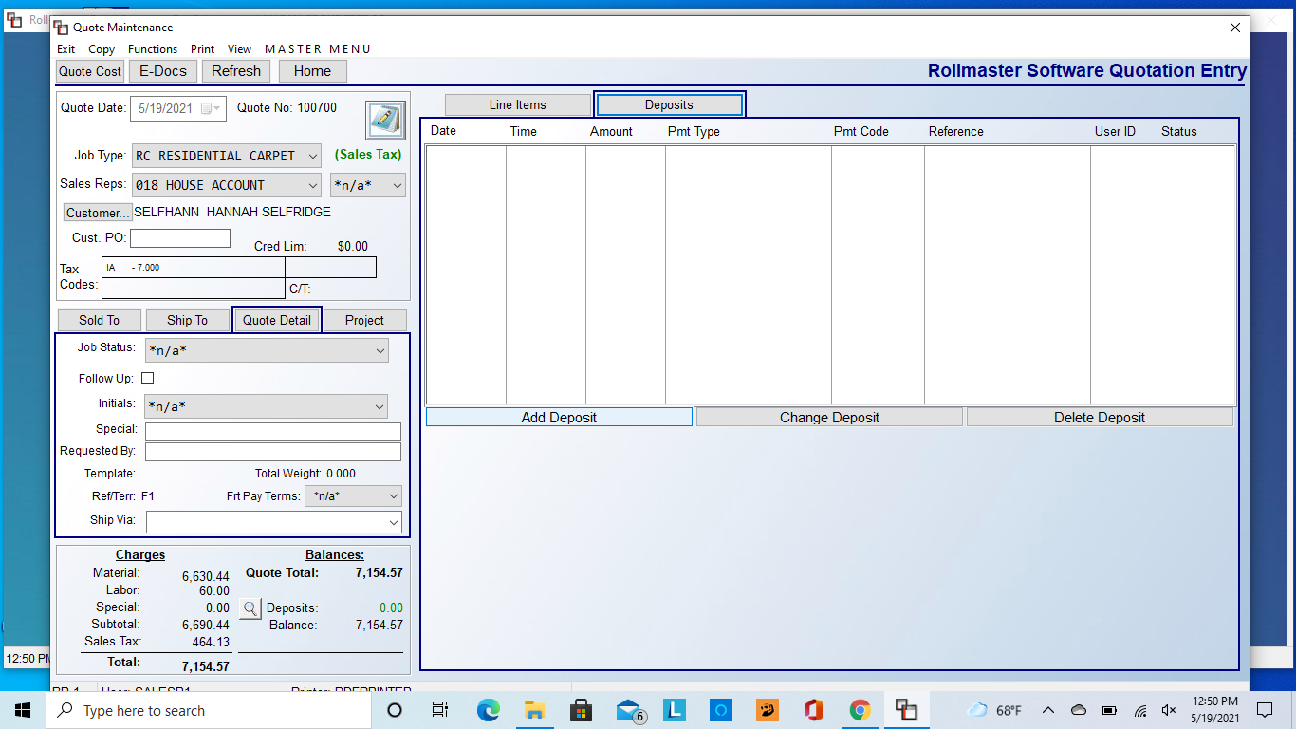
Once you are back to this screen, select Deposits to add down payments, financing, etc. Click Add Deposit
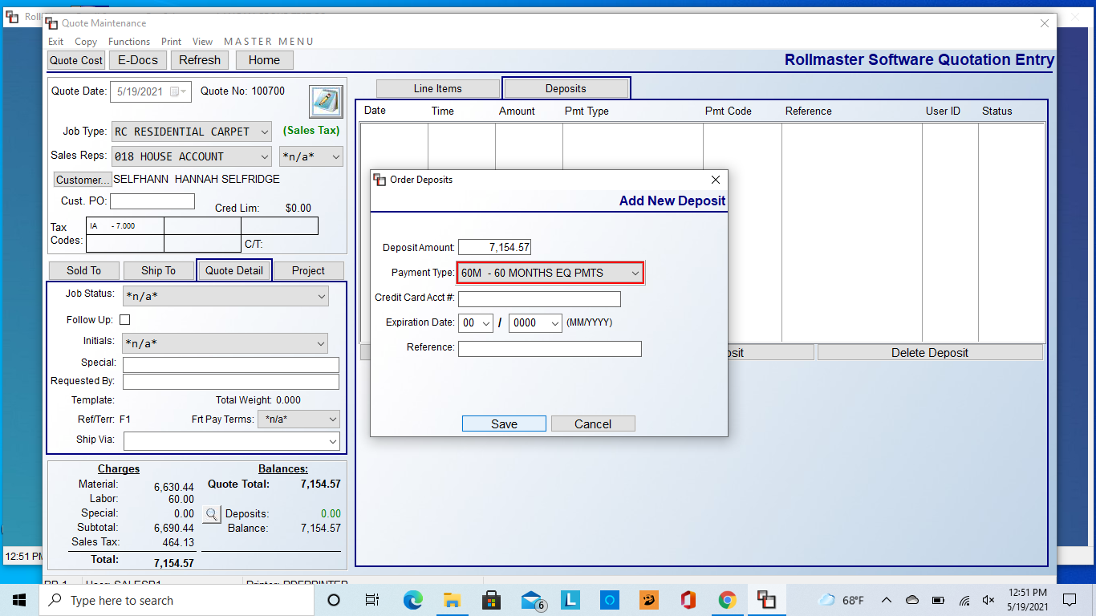
Type in the deposit amount, for financing, enter in the total order amount.
To select the type of payment, click on the Payment Type dropdown bar. Select the payment type and then select save
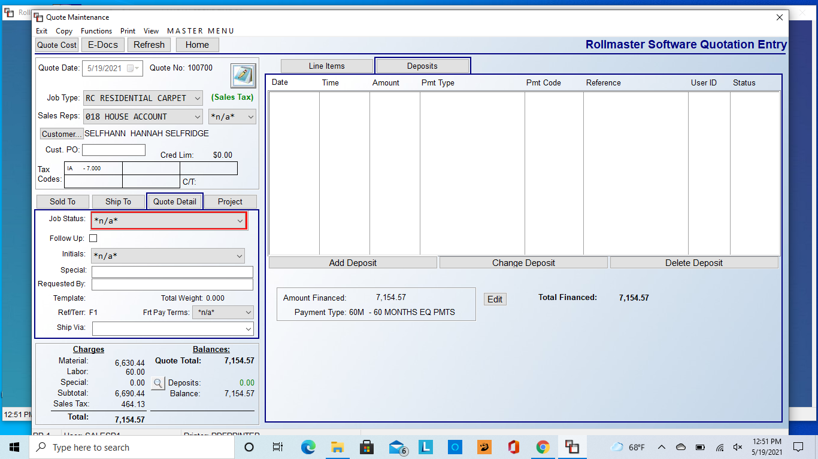
The deposit you added will appear below the Add Deposit button
If your quote is complete, you can exit out of this screen.

To convert a quote to a job
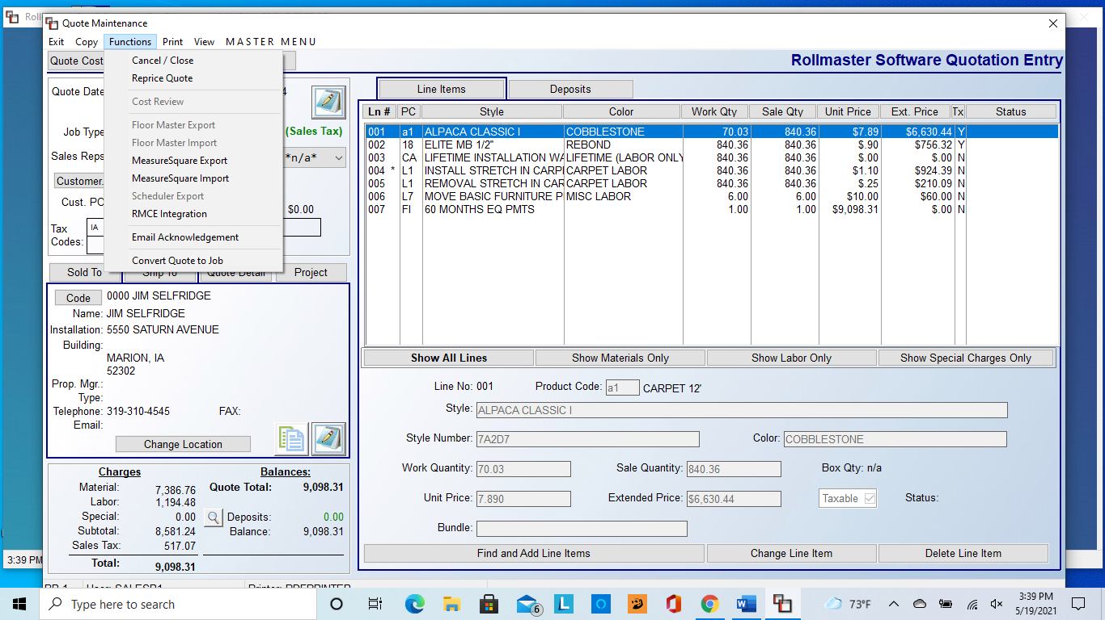
Open the quote you want to convert, click Functions at the top, and select Convert Quote to Job

There are multiple ways to search for products
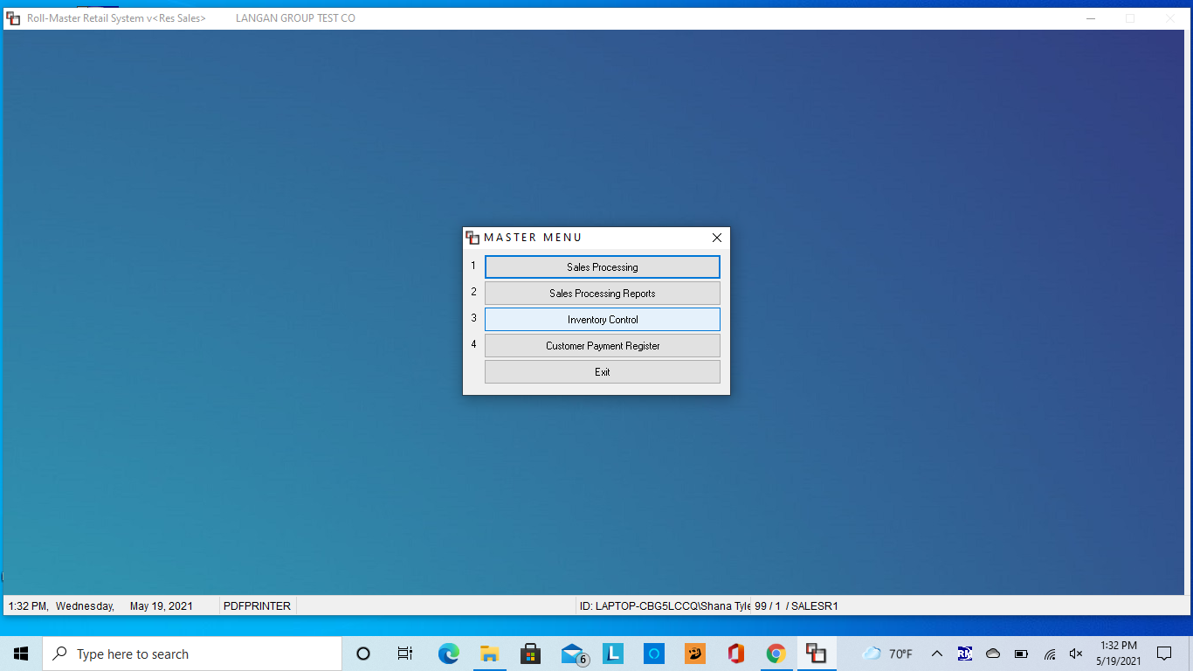
Go to Inventory Control
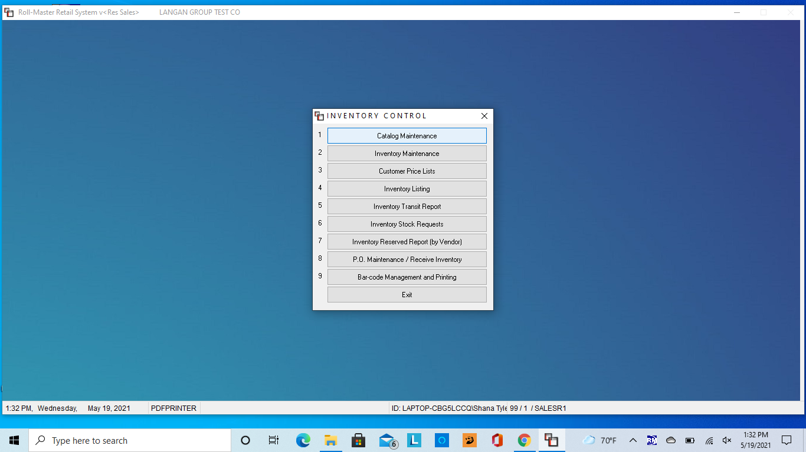
Then Catalog Maintenance
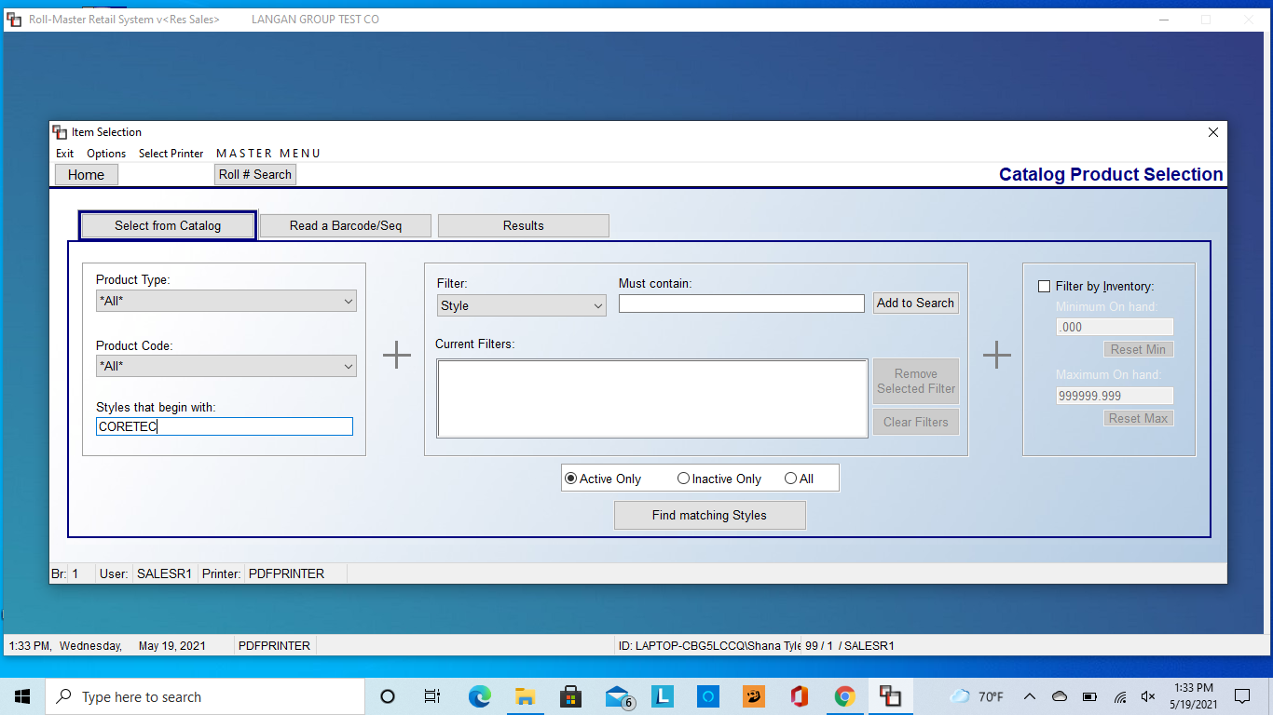
You will be able to search for product the same way you would when building a quote
In this case, I am searching for a COREtec product
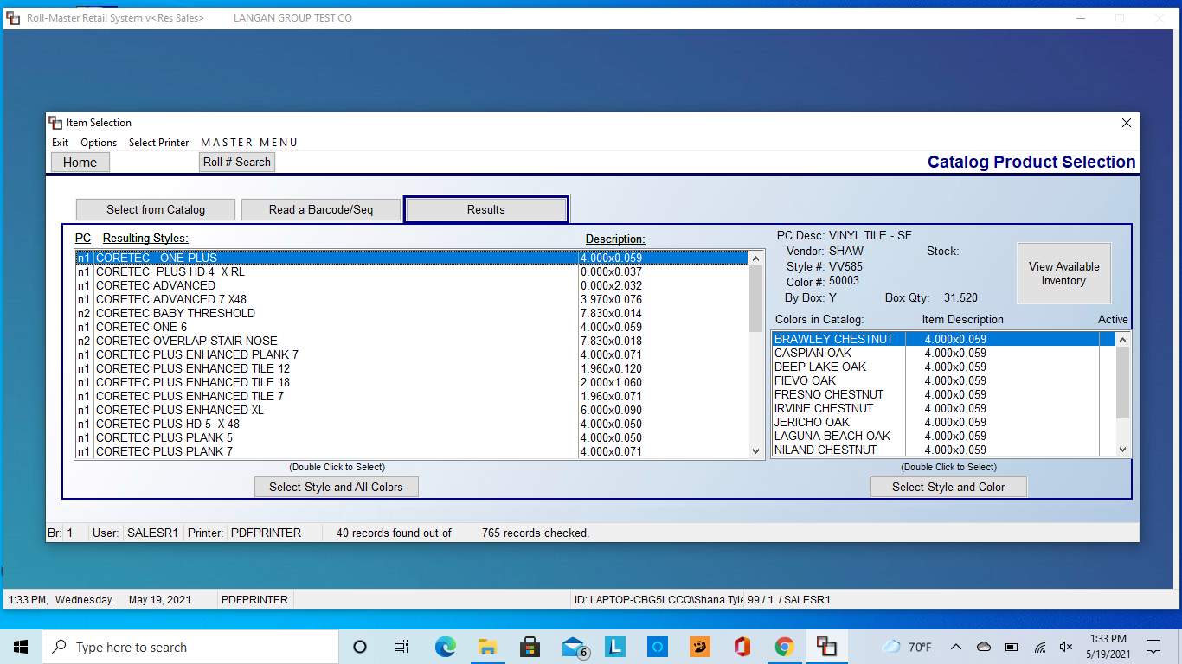
When I hit Find Matching Styles, a ton of results come up. Instead of sifting through it, I can search for the specific product I am looking for a different way.
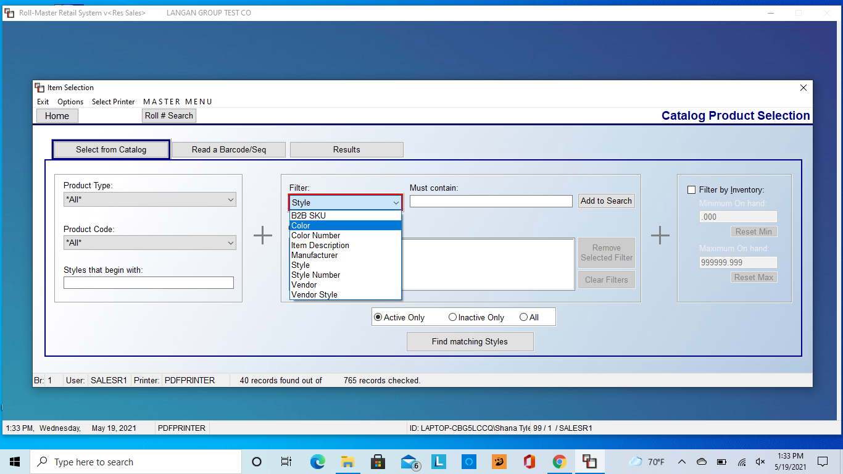
Under Filter there are several parameters I can search under. The easiest search is for color name or number, as this will narrow the results significantly
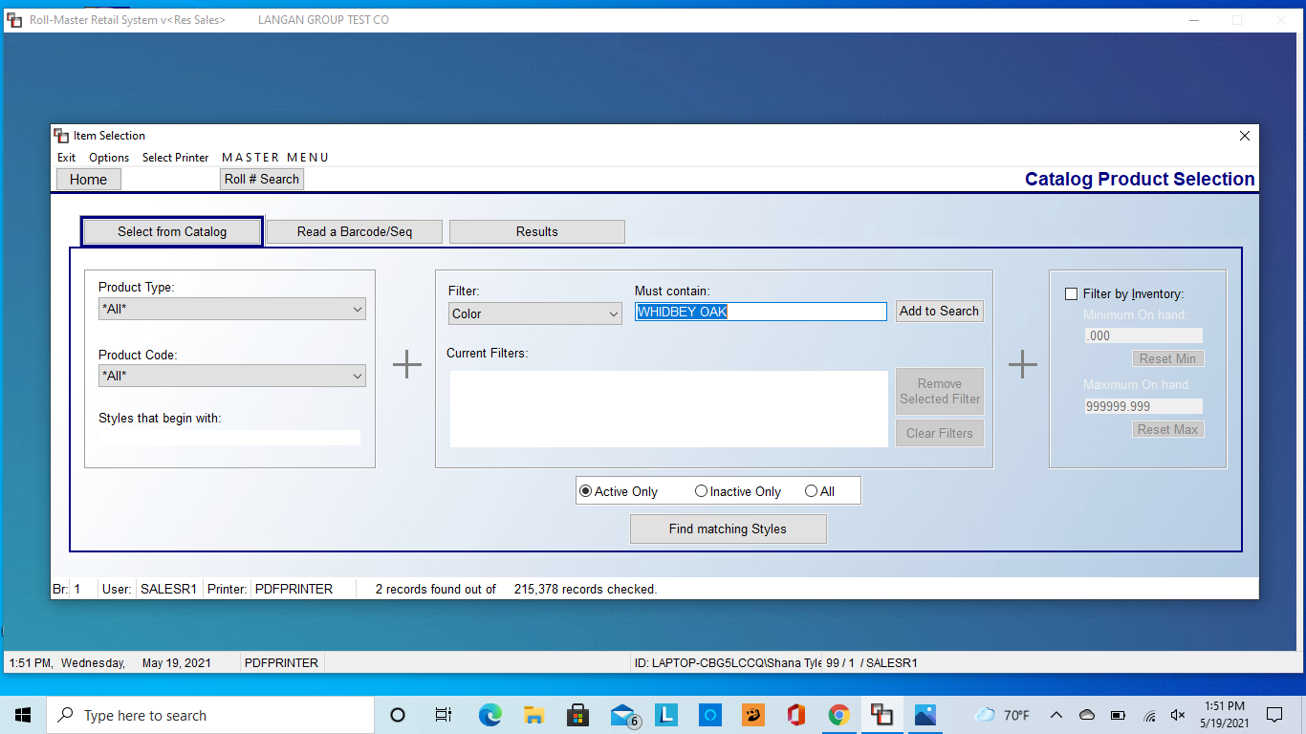
I am looking for COREtec, color Whidbey Oak. Under Filter, I select Color then type Whidbey Oak under Must Contain. Then click Add to Search. It will appear under Current Filters. Then click Find Matching Styles.
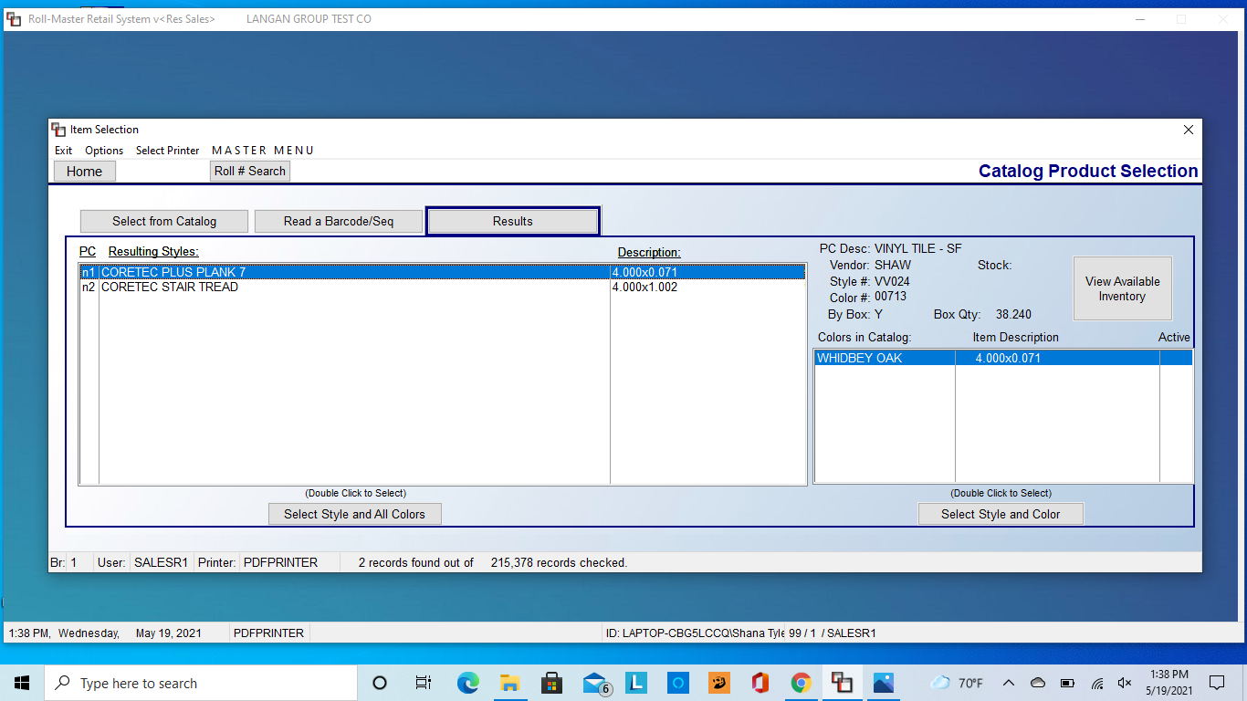
The results are much narrower this time, and I am able to easily find the product I am searching for

